Experiment No. 1.9

Student Name: Parvinder Singh UID: 22MCC20043
Branch: MCA - CCD Section/Group: 22MCD-1/ Grp B
Semester: III
Subject Name: DevOps Process Automation Lab Subject Code: 22CAP-745

- Aim/Overview of the practical:
- Create Manifest file in Puppet Server to install http
- Check it in Puppet Agent machine to start the services of http

- Code for experiment/practical:
- Create Manifest file in Puppet Server to install http

- Once Puppet-Master and Puppet-Slave connection is configured, Go to Puppet-Master machine.
- Create a manifest file site.pp # sudo nano /etc/puppet/code/environments/production/manifests/site.pp

class webserver{
package { ‘apache2’:
ensure => ‘installed’,
}

service { ‘apache2’:
ensure => ‘running’,
enable => true,
require =>Package[‘apache2’],
}
}

Save it. Ctrl+O, then Enter, then Ctrl+X.

- Then check the file by opening it.
# sudo nano /etc/puppet/code/environments/production/manifests/site.pp

- Manifest file is created successfully
- Now restart the puppet-master services.
# sudo systemctl restart puppet-master

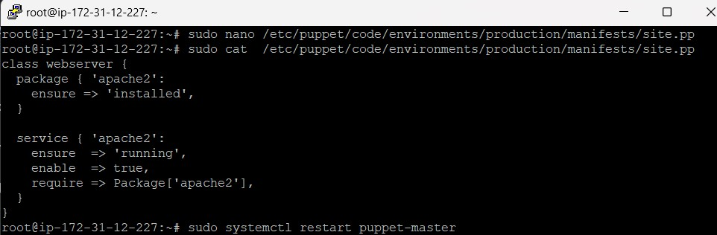

- Check it in Puppet Agent machine to start the services of http

- After creating the manifest file on Puppet-Master machine, Now go to Puppet-Slave machine for start services of http manifest file.
- Run # sudo puppet agent --test

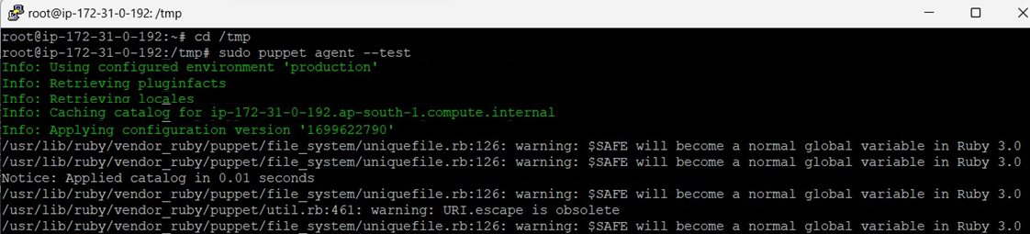

- Now to any web browser and type the ipv4 public address of your Puppet-Slave machine (in my case it is 62.0.32.34)

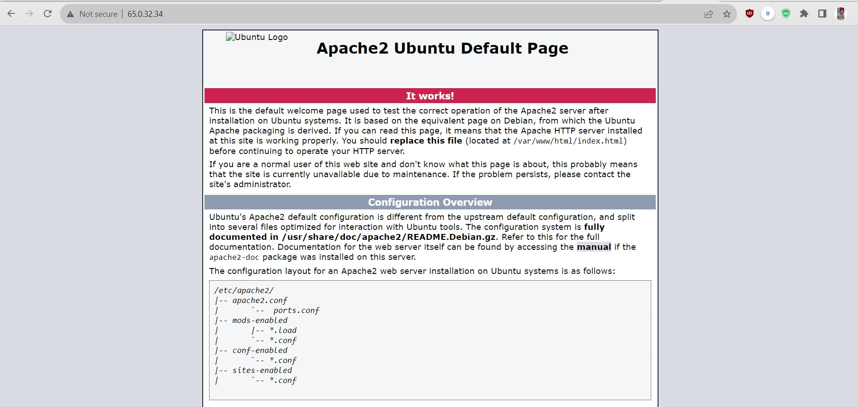

- Manifest file services are configured and started successfully.

